NAME: ________________________________

Instructions for Summer Assignments 2017

* To download your summer assignment, start by going to the OVMS homepage:

<http://wtps.org/Domain/15>

* Click the link for Students:

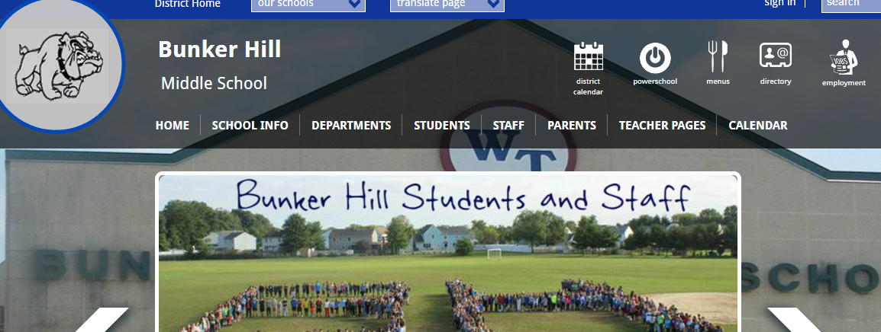

* Click the link for Summer Assignments:

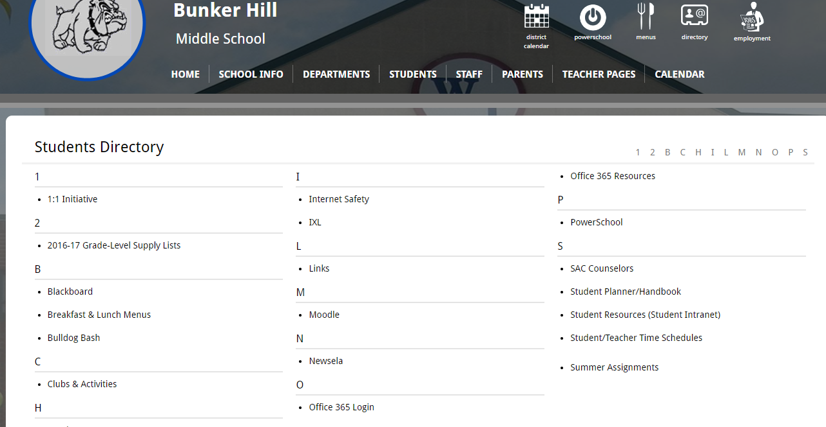

* This link will yield the summer math assignment web page.
* Click on the course you are entering next school year and then download, complete and print the assignment.
* All assignments are **due** the first day of school